

National Taiwan Craft Research and Development Institute
2026 Open Call for the Zhongxing International Craft Village
Residency Program Open Call Guidelines

1. Basis of the Program
This program is implemented in accordance with the Taiwan Craft Cultural Industry Mid- and Long-term Development Plan (2023–2026) under the initiative for the establishment and operation of international craft villages.

2. Program Objectives
To promote international and local cultural exchange and collaboration, the National Taiwan Craft Research and Development Institute (NTCRI) is establishing the Zhongxing International Craft Village at the former Bank of Taiwan staff housing complex in Zhongxing New Village, Nantou City. The Craft Village will provide professional creative resources and a space for local dialogue, while serving as a hub for international craft exchange.
This residency program aims to provide craft practitioners with on-site support and creative inspiration from working in a new geographical context through its inaugural craft residency open call. During the residency, participants will engage with the region’s distinctive natural ecology and cultural landscape, connecting with the roots of Taiwan’s craft industry. Through exchanges between international craft practitioners’ own experiences and the local culture, natural environment, history, and related cultural issues, residents are encouraged to transform these cross-cultural experiences and impressions into creative practices and craft works that respond to the spirit of the place.

3. About Zhongxing International Craft Village
Zhongxing New Village was Taiwan's first urban planning project to adopt the British Garden City concept. The former Bank of Taiwan dormitory complex represents modernist architecture, with functionality serving as its primary design principle. The site is designated as a Category I Cultural Landscape, officially registered as a cultural landscape by the Nantou County Government on 12 April 2011.
The Zhongxing International Craft Village is located on state-owned land encompassing Lots No. 182, 561, and adjacent parcels in Guangda Section, Nantou City, Nantou County. The site slopes gently from east to west, with all buildings situated on the upper terrace. It covers approximately 6,645 m² and comprises seven buildings with a total floor area of approximately 2,268 m².
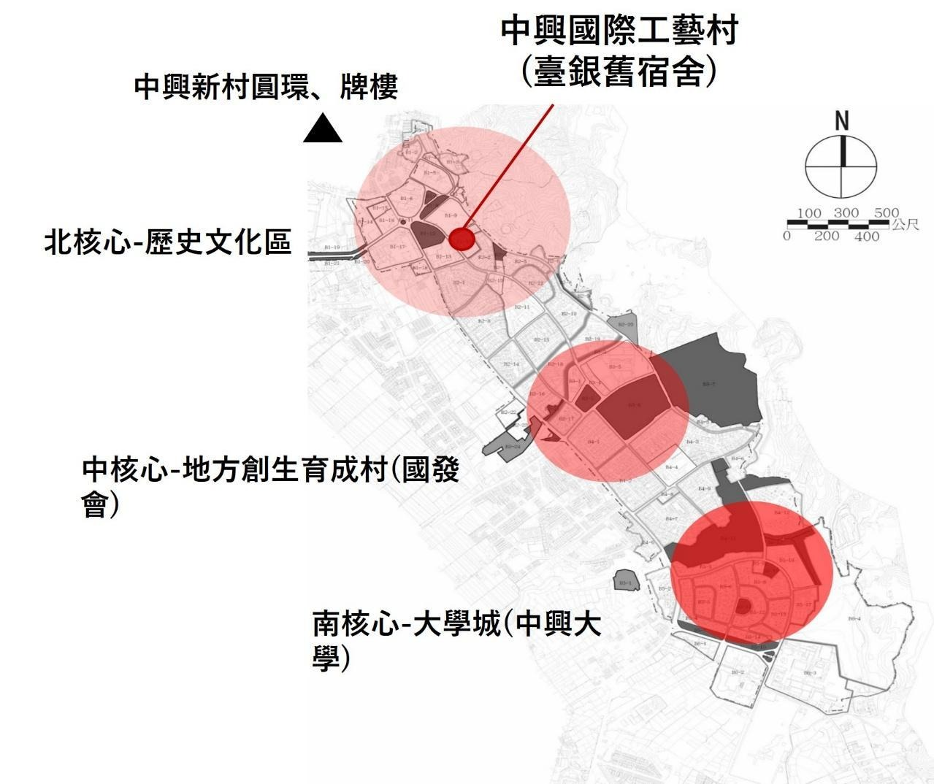
中興新村北、中、南核心分布圖
Northern, Central & Southern Hubs of Zhongxing New Village

- Zhongxing International Craft Village
- Zhongxing New Village Roundabout & Archway
- Northern Hub: Historic & Cultural District
- Central Hub: Regional Revitalization Incubation Village (National Development Council)
- Southern Hub: University District (National Chung Hsing University)
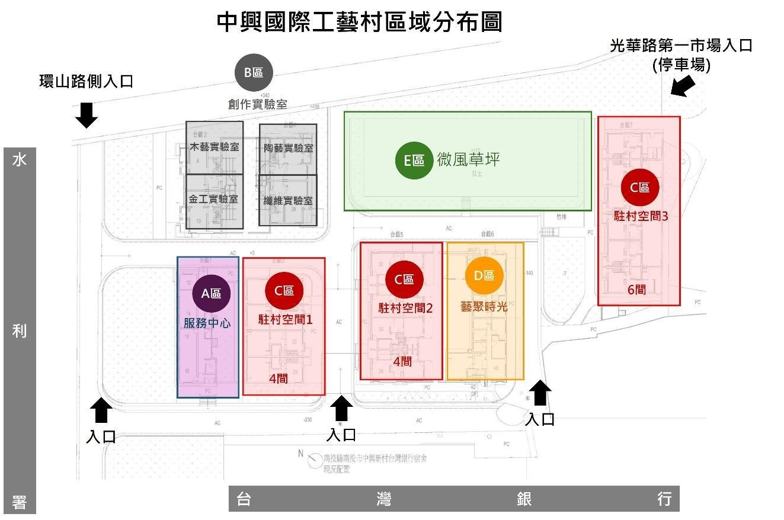
中興國際工藝村區域分布圖
Site Map of Zhongxing International Craft Village
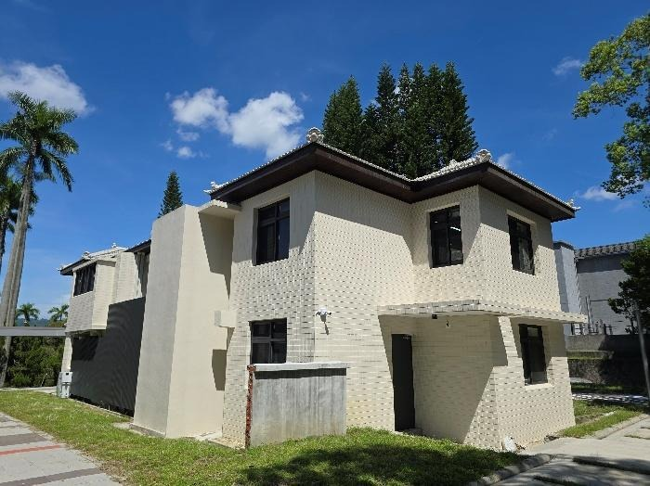  服務中心Visitor Center | 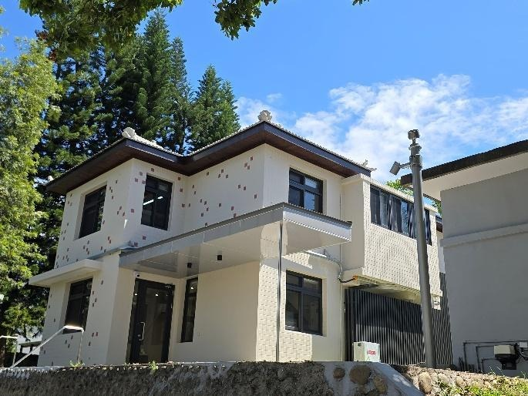  服務中心Visitor Center
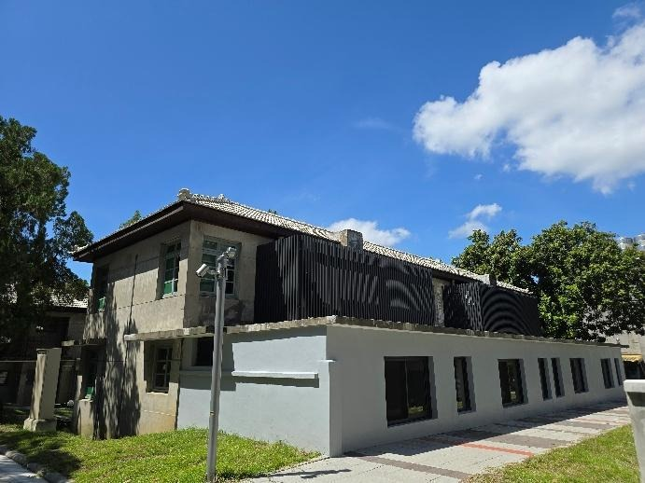  駐村空間1  Artist Lodge １ | 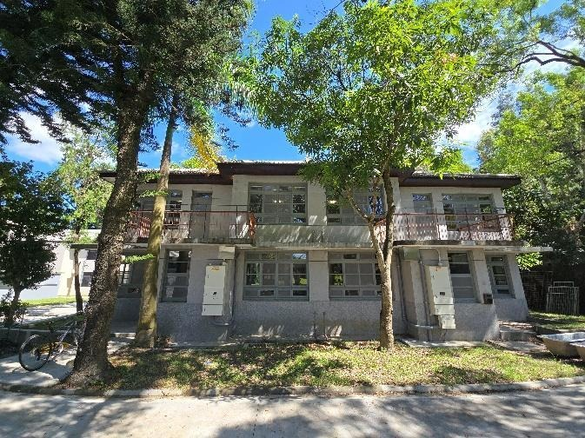  共用工坊  General Studio
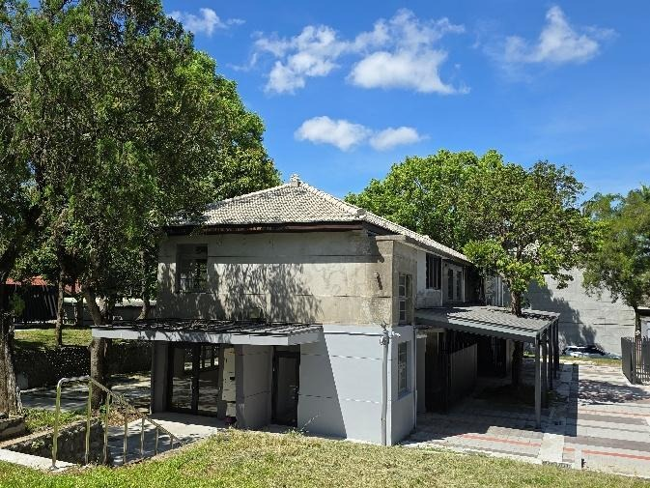藝聚時光  The Hive - Social Gallery & Cafe | 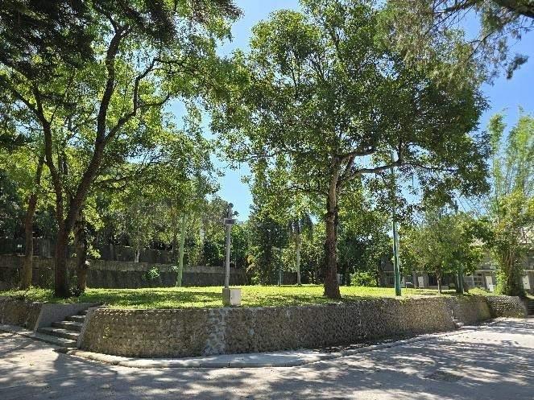  微風草坪  Breezy Meadow

4. Organizers
Organizers
Ministry of Culture
National Taiwan Craft Research and Development Institute (NTCRI)
Program Administrator
Fabrika Co., Ltd. (commissioned by NTCRI to manage the residency open call, residency coordination, artist support, and grant administration.)
5. Residency Location
Zhongxing International Craft Village
No. 8–46, Huanshan Road, Nantou City, Taiwan, Artist Lodge 1（Section C）

6. Program Schedule
The following schedule is tentative.
Actual dates are subject to the official announcement by NTCRI.
Open Call | August – September 2026
Review Period &  Results Announcement | September – October 2026
Residency Period | For three months between October and December 2026. Check-in must be completed by Monday, October 26 (inclusive).

*NTCRI reserves the right to adjust the program schedule when necessary.

7. Application Information
A. Eligibility
- Domestic Applicants：Taiwanese individuals or groups engaged in craft practice.
- International Applicants：Foreign nationals or holders of a valid ARC engaged in craft practice. Applicants should have basic proficiency in both Chinese and English.
- Individual Applicants：At least 20 years old and not currently enrolled as a student.
- Group Applicants：Registered Taiwanese craft-related organizations or associations with at least two members (maximum three residency participants). Applications must include a collaborative portfolio and individual CVs. Team members must be Taiwanese nationals and may not be changed after submission.
B. Number of residencies
- Domestic applicants: 2 individuals/groups, with 2 alternates.
- International applicants: 2 individuals, with 2 alternates.
- NTCRI reserves the right to adjust the number of accepted applicants according to program needs.

C. Application Procedure
- Applications must be submitted online. Applicants are required to complete and upload the following documents (Attachments 1–4). All documents must be typed, converted to PDF format, and submitted digitally. Application materials must be emailed to fabrika@ntcri.gov.tw, with each attachment limited to 20 MB. Incomplete applications must be completed by the specified deadline or will not be reviewed.

- Required Documents
- Residency Application Form (Attachment 1)
- Residency Project Proposal (Attachment 2)
- Portfolio of Major Works (Attachment 3)
- Consent Form for the Collection, Processing and Use of Personal Data (Attachment 4)
- Residency Agreement (Attachment 5) (for reference; to be signed upon acceptance)
- Copyright License Agreement (Attachment 6) (for reference; to be submitted upon acceptance)
- If application files exceed the upload limit, applicants should provide a cloud storage link. The email subject line should read: 2026 Zhongxing International Craft Village – Residency Program Open Call. Applications that are incomplete, submitted after the deadline, or fail to comply with the application requirements will not be considered.
- All submitted materials will not be returned. Applicants are advised to retain copies for their records.
D. Application Deadline
From now until September 30, 2026 (Wednesday), 23:59 (GMT+8). Late applications will not be accepted.

8. Selection Process
- Preliminary Review：Applications will undergo a preliminary review. Only shortlisted applicants will proceed to the final review. Unsuccessful applicants will not be notified.
- Final Review : A 5–7-member committee of experts appointed by NTCRI will conduct the review fairly and impartially. The review meeting will not be open to the public to protect applicants’ privacy.
- Selection Results
- The results will be announced on the NTCRI website. Selected applicants will also be notified individually by official letter and email.
- Selected individuals or teams must sign the “2026 Zhongxing International Craft Village Residency Program Agreement” within the specified period. Failure to do so will be deemed a withdrawal, and the vacancy will be filled from the waiting list. Overseas applicants may sign separately.

9. Residency Period
The residency period is three (3) months, tentatively scheduled between October 2026 and December 2026. The actual residency dates will be arranged separately. The residency period includes the presentation or exhibition of completed work.

10. Support Provided by NTCRI to Residents:

A. Living and Creative Spaces
a. Free use of a two-story residency space at the Craft Village, with a creative workspace on the first floor and living quarters on the second floor.
b. Basic furniture and appliances are provided free of charge (including kitchen facilities, bedding, Wi-Fi, air conditioning, refrigerator, induction cooker, washing machine, etc.). Residents are responsible for proper use and any repair costs resulting from misuse. Use of personal appliances requires prior approval from NTCRI staff and must comply with safety regulations.
c. Water and electricity are provided free of charge during the residency.

B. Creative Labs
a. Residents shall provide their own materials and tools and cover all related shipping costs.
b. Residents may apply to use basic equipment in the four Creative Labs—woodworking, metalwork, fiber, and ceramics—free of charge. Free consultation on the use of craft equipment is also available.
c. Residents are responsible for the proper use and care of all provided equipment and tools and shall bear any repair costs resulting from misuse. Use of personal equipment or tools requires prior approval from NTCRI staff and must comply with safety regulations.

C. Other Support
Reception and administrative support related to the residency project will be provided.

D. Financial Support
Each resident or team may receive up to NT$620,000, including living expenses, production fees, and other related expenses, as follows:
- Living Expenses
- NT$1,000 per person/team per day, calculated at 30 days per month. For a three-month residency (90 days), the maximum is NT$90,000.
- The payment schedule shall be agreed upon by Parties B and C and reported to Party A before payment is made.
- Production Fee
NT$150,000 per person/team.
- Other Expenses
Up to NT$380,000 for Includes costs related to the artwork and creative process, such as materials, prototyping, production, insurance, transportation, installation, removal, and exhibition maintenance. Reimbursement will be made upon submission and approval of supporting documents.
- Airfare
International residents will receive one round-trip economy-class ticket between their place of residence and Taiwan. Airport transfers to and from NTCRI will be provided. Residents who already hold Taiwan residency status are not eligible for airfare support.

E. Insurance
Residents must have accident and medical insurance during the residency. Insurance will be arranged by the program administrator, with the cost deducted from the “Other Expenses” budget.

11. Resident Obligations
- Residency Artwork
Residents shall complete one (1) craft work during the residency. The work must be suitable for outdoor display and completed by the opening of the Craft Village (tentatively December 2026). Details such as size, materials, and creative concept shall be described in Appendix 2. The creative process should incorporate public participation and local resources where appropriate.
The installation location shall be discussed with NTCRI and the program administrator during the residency. Residents shall also provide artwork descriptions for exhibition and promotional purposes.
- Open Studio Activities
Residents shall complete the basic setup of their studio exhibition space within one (1) month of arrival and participate in one Open Studio event per month, as well as other exchange or promotional activities organized by NTCRI.
- Documentation and Publicity
Residents should allow NTCRI and the program administrator to collect necessary written, photographic, audio, and video documentation of the residency for NTCRI’s non-commercial education, research, promotion, and publicity purposes.
- Creative Materials
Residents shall provide documentation of their creative process, such as sketches, photographs, videos, and artwork descriptions, for use by NTCRI and the program administrator in exhibitions, publications, websites, social media, and other promotional activities.
- Final Report
Residents shall submit a residency report of at least 2,000 words in Chinese or English, including photographs of the artwork and residency activities, no later than 15 days before the end of the residency. Residents shall also complete an online residency feedback survey.
- Residency Attendance
The residency period is three months, with at least 20 residency days required per month. If the actual residency is fewer than 20 days in any month, the living allowance will be paid based on the actual number of residency days.

12. Terms & Conditions
- Agreement Signing
Selected craft practitioners shall sign and submit the agreement provided by NTCRI within seven (7) working days from the day following receipt of notification. Failure to do so by the deadline will be deemed a withdrawal, and the next applicant on the waiting list will be notified.
If a selected applicant is unable to participate or follow the scheduled residency period, the applicant will be deemed to have withdrawn unless otherwise approved by NTCRI.
- Ownership and Rights of Residency Works
- Residency Artwork

The work shall remain the property of the resident and be exhibited outdoors at the Craft Village for three months. The work must be properly managed and maintained during the exhibition period.After the exhibition period, the resident shall retrieve the artwork. Removal and transportation costs may be covered under “Other Expenses.”

Failure to complete the artwork during the residency shall constitute a failure to fulfill the Agreement and will be handled in accordance with Article 11, Paragraph 1 of the Agreement. The resident will also be ineligible to apply for another Craft Village residency for three (3) years.
- Residency Documentation and Related Works

NTCRI may use documentation and related works produced during the residency, free of charge and without limitation as to time or territory, for non-commercial promotion, education, or research. The creator may not charge exhibition loan fees or royalties for such use.

NTCRI shall credit the creator when using such materials. The creator agrees not to assert moral rights with respect to minor modifications necessary for exhibitions, publicity, or administrative purposes.

The parties shall execute five (5) copies of the authorization agreement (Appendix 6): one original each for the resident, the program administrator, and NTCRI, with two duplicate copies retained by NTCRI.
- Changes and Interpretation

NTCRI reserves the right to modify the residency program and make the final interpretation of its provisions. In the event of natural disasters, severe infectious diseases, or other force majeure events, NTCRI may adjust the program and take appropriate measures accordingly.

Any matters not covered herein may be further specified or supplemented in the agreement signed by the parties.
- Residency Inquiries
- Application Inquiries
Applicants should carefully review all relevant documents. For inquiries, please contact Ms. Tang during the application period, 10:00–16:00:
2026 Zhongxing International Craft Village – Residency Program Open Call
Email: fabrika@ntcri.gov.tw
Mobile: 0928-716607
Tel: 02-28226250
- Site Visit Inquiries

To arrange a site visit, please contact Ms Hsieh and Ms. Lin during the application period, between 10:00 and 16:00 on working days:

Tel: (049) 233-4141, Ext. 366

Attachment 1
National Taiwan Craft Research and Development Institute
2026 Zhongxing International Craft Village
Residency Program Open Call Application Form

Residency Project Title |  |  | photo taken within the past three months.
Artwork Title
Applicant / Group Name
Group Registration No.
Proposed Residency Period | From ______ / ______ / ______ to ______ / ______ / ______  (Residency is expected between October and December 2026, for up to three months. Actual dates will be arranged by the program administrator.)
Applicant Information
Date of Birth (YYYY/MM/DD) |  | Gender | □M □F □N/A
Nationality |  | National ID / Passport No.
Current Place of Residence
Education
Current Occupation
Telephone | （H） （O） （Cell）
Contact Address
E-mail
Emergency Contact |  | Contact Number

Note 1: For group applications, please provide the above information for all members.
Note 2: Add additional rows as needed.

Attachment 2
National Taiwan Craft Research and Development Institute
2026 Zhongxing International Craft Village
Residency Program Open Call
Project Proposal

I. Individual / Group Statement (Maximum 500 Words)
II. Individual / Group Education and Experience
(Including education: school, major, degree, and year of graduation; and experience: work history, exhibitions or presentations, major works/portfolios, awards, international residencies or exchange programs, etc.)
III. Residency Proposal (May include, but is not limited to, the following)
(1) Motivation for the Residency
(2) Residency Goals and Creative Concept
(3) Proposed Residency Artwork and Implementation
(including artwork title, dimensions, craft materials, sketches, etc.)
(4) Public Participation and Use of Local Resources
(5) Project Timeline (please present as a Gantt chart)
(6) Estimated Budget
(7) Expected Results
(8) Other Supporting Information (for the selection committee’s reference)
Note 1: For group applications, Sections I and II must include information on each member as well as an introduction to the group.
Note 2: Additional supporting materials for review may be uploaded as a PDF file under 2 MB.

Attachment 3
National Taiwan Craft Research and Development Institute
2026 Zhongxing International Craft Village
Residency Program Open Call Project
Portfolio of Major Works (Individual / Group Application)
Title of Work |  | Year Created
Dimensions
Materials
Techniques
Concept and Features
Image of the Work

Note 1: Please submit three representative works for review.
Note 2: Please use one form for each work.

Attachment 4
National Taiwan Craft Research and Development Institute
2026 Zhongxing International Craft Village
Residency Program Open Call
Consent to the Collection, Processing, and Use of Personal Data

The National Taiwan Craft Research and Development Institute (NTCRI) hereby informs you of the following matters in accordance with Article 8, Paragraph 1 of the Personal Data Protection Act of Taiwan. Please read this consent form carefully.

1. Purpose of Collection
Your personal data will be collected, processed, and used solely for the administration and implementation of the 2026 Zhongxing International Craft Village Residency Program Open Call.

2. Categories of Personal Data
The personal data collected may include full name, affiliation, job title and contact information.

3. Retention Period
Your personal data will be retained from the date of signing this consent form until the completion of the above-mentioned program and the fulfillment of the stated purposes.

4. Area of Use
Your personal data may be used within the Republic of China (Taiwan) and in the areas where the 2026 Zhongxing International Craft Village Residency Program Open Call is implemented.

5. Recipients of Personal Data
Your personal data may be accessed and used by the Institute and the organizations responsible for administering the residency program.

6. Methods of Use
Your personal data may be processed and used through Internet-based systems, email correspondence, electronic databases, written documents and facsimile (fax).
In accordance with Article 3 of the Personal Data Protection Act, you have the right to request that the Institute:
(1) Provide access to or allow inspection of your personal data.
(2) Provide copies of your personal data.
(3) Correct or supplement your personal data.
(4) Cease the collection, processing, or use of your personal data.
(5) Delete your personal data.
To exercise any of the above rights, please contact the program coordinator.
You may choose whether or not to provide your personal data. However, if you choose not to provide the required information, the Institute may be unable to process your application or provide services related to the purposes stated above.

Declaration
I have read and understood the above information and hereby consent to the collection, processing, and use of my personal data as described above.
Signature: ___________________________
Date: ______ / ______ / ______

Attachment 5 (For Reference Only – Agreement to Be Executed Upon Selection)

National Taiwan Craft Research and Development Institute
Tripartite Agreement for the 2026 Zhongxing International Craft Village
Residency Program Open Call

Year:
Applicant / Group:
Project Title:

This Agreement is entered into by and among the following parties:
Party A: National Taiwan Craft Research and Development Institute (hereinafter referred to as "Party A"), the Organizer;
Party B: ________________________________ (hereinafter referred to as "Party B"), the Resident Artist / Resident;
Party C: Fabrika Co., Ltd. (hereinafter referred to as "Party C"), the Program Administrator commissioned by Party A.
For the implementation of the 2026 Zhongxing International Craft Village Residency Program Open Call, the Parties hereby agree to enter into this Agreement under the following terms and conditions.

Article 1. Purpose of Use
Party A shall provide Party B with residency space located at the Taiwan Bank Dormitory Complex, Zhongxing New Village (No. 8–46, Huanshan Road, Nantou City) for use during the residency period. Party B shall use the assigned residency space only in accordance with the approved residency proposal and within the area designated by Party A. During the residency period, Party C, as commissioned by Party A, shall be responsible for administering residency-related services, including program guidance, administrative support, and the review and disbursement of program funds.

Article 2. Residency Period
The residency period shall commence on _____ and end on _____, for a total of _____ days. Party B shall use the residency space for the approved residency period as specified in the application proposal. No extension of the residency period shall be permitted unless it has been reviewed by Party C and approved by Party A. Upon the commencement of the residency, Party B shall be issued _____ key(s) and one set of access codes to Residency Space No./Name: ___________. The keys shall not be duplicated. Party B may freely access the assigned residency space throughout the residency period. Prior to completing the check-out procedures, Party B shall return all keys to Party C for inspection and verification. Upon confirmation, the keys shall be returned to Party A.

Article 3. Residency Schedule

1. Party B shall submit a residency schedule and shall be physically present at the residency for at least twenty (20) days per month. If Party C verifies that Party B’s actual residency days in any month fall below the required minimum, the living allowance shall be paid based on the actual number of residency days.

2. During the residency period, Party B’s activities shall be limited to Taiwan proper and its outlying islands (Taiwan, Penghu, Kinmen, and Matsu). Party B shall remain subject to the requirement of at least twenty (20) residency days per month.

3. If, for creative purposes, Party B needs to conduct fieldwork outside the Craft Village for ten (10) days or more, including data collection, material gathering, research, or similar activities, Party B shall submit a request to Party C at least ten (10) working days prior to departure. Such travel may proceed only after review by Party C and approval by Party A. Any such travel undertaken without prior approval shall be counted as days not physically present at the residency.
Notwithstanding the foregoing, Party B shall complete at least sixty (60) actual residency days during the three-month residency period (20 days × 3 months). If Party B fails to meet this minimum, the living allowance shall be paid based on the actual number of residency days.
Article 4. Contract Amount and Payment
- The maximum total amount payable to each individual or group shall be NT$620,000, including living expenses, creative fees, and other expenses. Party C shall be responsible for reviewing the relevant documents and processing all payments.
- Payment Terms
- Living Expenses
The maximum amount payable to each individual or group for living expenses shall be NT$90,000.
- Living expenses shall be paid at NT$1,000 per person/group per day, calculated on the basis of 30 days per month, to cover meals, transportation, and miscellaneous expenses. For a three-month residency of 90 days, the maximum amount payable shall be NT$90,000.
- The payment schedule shall be agreed upon by Parties B and C and reported to Party A for record before payment is processed.
- Party B shall complete at least twenty (20) residency days per month. If Party B fails to meet this requirement, the living expenses for that month shall be paid based on the actual number of residency days.
- Creative Fee
The total creative fee payable to each individual or group shall be NT$150,000, payable in two installments.
- First Installment: Within ten (10) working days from the date of execution of this Agreement, Party B shall submit the residency proposal to Party C. Upon Party C’s initial review and Party A’s final approval, Party C shall pay 50% of the total creative fee, or NT$75,000, in accordance with the payment procedures.
- Second Installment: Party B shall complete the artwork and participate in the required exchange activities before the end of the residency. No later than ten (10) working days before the end of the residency, Party B shall submit to Party C a residency report of at least 2,000 words, together with photographic documentation. Upon Party C’s initial review and Party A’s final approval, Party C shall pay the remaining 50% of the total creative fee, or NT$75,000, in accordance with the payment procedures.
- Other Expenses
The maximum amount payable for other expenses shall be NT$380,000.
- Eligible expenses includes costs related to the artwork and creative process, such as materials, prototyping, production, insurance, artwork transportation, installation, removal, and management and maintenance during the exhibition period.
- Party B shall submit relevant receipts and supporting documents to Party C for review. Upon approval, Party C shall process payment in accordance with the payment procedures.
- Airfare
The maximum airfare allowance shall be NT$40,000 per person.
- Party B of foreign nationality shall be provided with one round-trip economy-class airfare between their place of residence and Taiwan. Transportation between the airport and the Craft Village shall be provided by Party C. No airfare allowance shall be provided if Party B of foreign nationality already holds Taiwan residency status.
- Airfare shall be reimbursed based on actual expenses. Party B of foreign nationality shall submit the boarding pass or ticket stub, e-ticket, proof of payment, and other required documents to Party C for review. Upon approval, Party C shall process the reimbursement in accordance with the payment procedures.
- All amounts payable under this Agreement are tax-inclusive and shall be paid by bank transfer. The foregoing amounts include any individual income tax and National Health Insurance supplementary premium payable by Party B.

Party C shall withhold and report the applicable taxes and premiums at the statutory rates and remit the net amount after withholding to Party B’s designated bank account.

For foreign nationals, income tax shall be withheld in accordance with the applicable tax laws of the Republic of China (Taiwan) (currently approximately 6%–20%), based on Party B’s actual residency status. Any matters not specified herein shall be governed by the applicable tax laws of the Republic of China (Taiwan).
- Party B shall submit all required documents and reports within the specified deadlines. Party B shall bear responsibility for any delay or failure in payment resulting from Party B’s failure to submit the required documents in accordance with with these provisions.
Article 5 Residency Requirements
- Residency Artwork
Party B shall complete one (1) craft work during the residency period. The work shall be suitable for outdoor display and completed by the opening of the Craft Village (tentatively December 2026). The creative process should incorporate public participation and local resources where appropriate. The installation location shall be discussed with Parties A and C during the residency. Party B shall also provide artwork descriptions and related materials for exhibition and promotional purposes.
- Open Studio Activities
Party B agrees to complete the basic setup of the studio exhibition space within one (1) month of arrival and participate in one Open Studio event per month, as well as other exchange or promotional activities organized by Party C during the residency.
- Documentation and Publicity
Party B shall cooperate with Party C in the necessary collection and documentation of written, audio, and visual materials for the residency program, and agrees to authorize the use of such materials (including images, text, or other forms) by Parties A and C for non-commercial educational, research, promotional, and publicity purposes.
4. Party B shall complete the residency project and fulfill all related obligations in accordance with the submitted proposal. Failure to complete them within the specified period will render Party B ineligible to apply for another residency for three (3) years.

Article 6. Use and Maintenance of the Residency Space
1. Party B shall exercise the duty of care of a prudent administrator in the use of the residency space. If the residency space is damaged or its value is diminished as a result of the intentional act or negligence of Party B, or of any third party permitted by Party B to use the residency space, Party B shall be liable for all resulting damages. If any third party suffers damage arising therefrom, Party B shall be liable to such third party. Should Party A incur any loss or liability (including liability for state compensation) as a result thereof, Party B shall indemnify Party A for all such losses and damages.
2. Party B shall be responsible for the safety of the residency space during the residency period and shall exercise the duty of care of a prudent administrator in maintaining the cleanliness of the residency space and the safety of its facilities. Party B shall also cooperate with inspections conducted by Parties A and C and the competent authorities.
3. With respect to any tables, chairs, equipment, tools, or other property loaned by Party A for use in the residency space, Party B shall exercise the duty of care of a prudent administrator. If any such property is damaged or lost, Party B shall be liable for all resulting damages.

Article 7. Force Majeure
If, due to a natural disaster, emergency, or any other event of force majeure, the residency space cannot be made available to Party B for the purpose specified in Article 1 of this Agreement, Party B shall promptly notify Party C.
Upon verification by Party C and submission to Party A for confirmation, this Agreement shall be terminated, and Party B shall vacate and return the residency space.

Article 8. Use of the Residency Space
1. Party B shall use the space as approved and shall not assign, sublease, lend, or transfer it to others. Any violation may result in termination of this Agreement.
2. Accommodation is for Party B only. Companions, family members, assistants, and pets are not permitted, except guide dogs.
3. Party A may reassign the residency space as needed for policy or operational reasons.
4. In support of energy conservation and carbon reduction, Party B shall minimize the use of air conditioning.
5. Party B shall not bring prohibited or hazardous items onto the premises and shall comply with waste-sorting and disposal requirements.
6. Party B shall avoid excessive noise. Accommodation privileges may be revoked if no improvement is made after three (3) warnings from Parties A and C.
7. Party B shall minimize the use of high-power electrical equipment to avoid overloading the electrical system or causing power outages.
8. Party B shall not attach or install anything that may damage the buildings or facilities. Any existing furniture or equipment shall not be moved without prior notice to Party A.
9. The residency site is a Category I Cultural Landscape. Party B shall not alter or damage any facilities or landscape features. Open flames and smoking are prohibited. Any activity affecting the premises requires prior approval from Party C.

Article 9. Assignment and Security Interest
Party B shall not pledge, assign as security, or otherwise use any rights arising under this Agreement as collateral or for any similar purpose.

Article 10. Termination of Use of the Residency Space and Damages
1. Party A may terminate Party B's right to use the residency space at any time under any of the following circumstances. In such event, Party B shall not claim any compensation or damages from Party A:
(1) Party B uses the residency space in violation of applicable laws or regulations.
(2) Party B damages the residency space or any facilities or equipment due to reasons attributable to Party B and fails to restore or repair such damage.
(3) The residency space is destroyed by fire due to reasons attributable to Party B.
(4) Party B undertakes any unauthorized addition, alteration, renovation, or construction of the residency space.
(5) Party B breaches any provision of this Agreement.
(6) This Agreement may be terminated in accordance with any other applicable laws or regulations.
2. The residency space is required for national policy implementation, urban planning, development or land use, public works, government operations, or any lawful change of use by the government.
3. Where Party B is in breach of this Agreement, Party B shall be liable for all resulting damages unless otherwise provided herein.
4. Before vacating the residency space, Party B shall first consult Party A as to whether the residency space may be returned in its existing condition. Unless otherwise provided in this Agreement or otherwise approved by Party A, Party B shall restore the residency space to its original condition before returning it to Party A.
5. Upon termination or expiration of this Agreement, Party B shall return the residency space to Party C by the agreed time on the final day. Any items left behind after Party C’s notice shall be deemed abandoned and may be disposed of by Party A. All disposal costs shall be borne by Party B.
6. If Party B intends to terminate the use of the residency space early, Party B shall submit a written request to Party C at least fifteen (15) days in advance. This Agreement may be terminated only if Party A determines that the circumstances constitute force majeure or are not attributable to Party B and provides written approval. Party B shall return any unused funds, with the amount and method of repayment to be agreed separately.

Article 11. Ownership and Rights of Residency Works
1. If Party B fails to complete the artwork within the specified period, such failure shall constitute a breach of the Agreement. Party B shall return the relevant funds, with the amount and method of repayment to be agreed separately, and shall be ineligible to apply for another Craft Village residency for three (3) years, unless an extension has been approved by Party A.
2. Party B shall warrant that its works and application proposal do not infringe upon the rights of any third party. If any such infringement causes damage to Party A’s reputation or results in any claim or loss, Party B shall bear full liability for all resulting damages.
3. Party B shall retain ownership of the artwork created during the residency. Upon completion, the artwork shall be exhibited in the outdoor area of the Craft Village for three (3) months. After the exhibition period, Party B shall retrieve the artwork, with removal and transportation costs covered under “Other Expenses.” If Party B fails to complete the artwork within the specified period, Paragraph 1 of this Article shall apply.
4. Party A may use documentation and related works produced during Party B’s residency (including text, audio, video, and images), without limitation as to territory, duration, or frequency, for non-commercial purposes such as education, research, exhibitions, promotion, publication, and project publicity. Party B shall cooperate with related presentations and shall not request or charge any exhibition fees, royalties, or other compensation.
5. Party A shall respect Party B’s moral rights when using or displaying the work and shall reasonably identify Party B as the creator (right of attribution). Party B agrees not to assert moral rights against Party A for minor modifications necessary for exhibition installation, promotion, publication layout, digital preservation, or collection maintenance.
Article 12. Dispute Resolution
1. The Parties shall perform this Agreement in good faith. In the event of any dispute arising out of or relating to this Agreement that results in legal proceedings, the Nantou District Court of Taiwan shall have exclusive jurisdiction as the court of first instance.
2. If any legal proceedings arise as a result of Party B's breach of this Agreement, Party B shall be responsible for all litigation costs and reasonable attorneys' fees incurred by Party A.
Article 13. Incorporation by Reference
The "2026 Zhongxing International Craft Village Residency Program Open Call Guidelines" and all application documents and supporting materials submitted by Party B and approved by Party A shall constitute an integral part of this Agreement.
Article 14. Amendments
Any matters not provided for in this Agreement may be amended or supplemented in writing with the consent of the parties.
Article 15. Execution
This Agreement is executed in five (5) counterparts, comprising three (3) original copies and two (2) duplicate copies. It shall become effective upon execution by all Parties.
Party A, Party B, and Party C shall each retain one (1) original copy. The two (2) duplicate copies shall be retained by Party A.
In the event of any discrepancy between an original copy and a duplicate copy, the original copy shall prevail.

Party A
National Taiwan Craft Research and Development Institute
Representative: ______________________
Address:
No. 573, Zhongzheng Rd., Caotun Township, Nantou County 542015, Taiwan
Telephone: +886-49-233-4141
Uniform Business Number (UBN): 61218607

Party B
Name: ______________________
National ID No. (For non-Taiwanese applicants, please provide your ARC or passport number): ______________________
Address: ______________________________________________
Telephone: ______________________

Bank Account Information
Bank Name: ______________________
Bank Code: ______________________
Branch Name: ______________________
Account Name: ______________________
Account Number: ______________________

Party C
Fabrika Co., Ltd.
Representative: ______________________
Address: ______________________________________________
Telephone: ______________________
Uniform Business Number (UBN): ______________________

Date: ______ / ______ / ______ (Republic of China [Taiwan] Calendar)
Attachment 6 (For Reference Only – To Be Signed Upon Selection)
National Taiwan Craft Research and Development Institute
2026 Zhongxing International Craft Village
Residency Program Open Call
Copyright License Agreement

The Consenting Party (Creator), participating in NTCRI’s “2026 Zhongxing International Craft Village Residency Program Open Call” (the “Project”), hereby agrees to the following terms of this Copyright License Agreement:

1. The Consenting Party warrants that the works and residency proposal do not infringe upon any third-party rights. The Consenting Party shall be fully liable for any resulting damage, claims, or liabilities incurred by NTCRI.
2. The principal artwork created by the Consenting Party during the residency (or a specific work mutually agreed upon before the end of the residency) shall remain the property of the resident, including both physical ownership and copyright. Upon completion, the work shall be exhibited outdoors at the Craft Village for three (3) months. After the exhibition period, the resident shall retrieve the work, with removal and transportation costs covered under the project’s “Other Expenses.”

3. With respect to collection works owned by NTCRI and documentation collected during the residency (including text, images, audio, and video), NTCRI may use such materials without limitation as to territory, duration, or frequency for non-commercial education, research, exhibitions, promotion, publication, and project publicity. The Consenting Party shall cooperate with related presentations and shall not charge any exhibition loan fees, royalties, or other compensation.

4. NTCRI shall respect the Consenting Party’s moral rights and identify the Consenting Party as the creator. The Consenting Party agrees not to assert moral rights against minor modifications necessary for exhibition, promotion, publication layout, digital archiving, or collection maintenance.

Name of Consenting Party (Creator): __________________________________
Passport No.: __________________________________
Telephone: __________________________________
E-mail: __________________________________
Registered Address: __________________________________

Date: ______ / ______ / ______

